recursive relation – Substitution ,Master thm, Tree met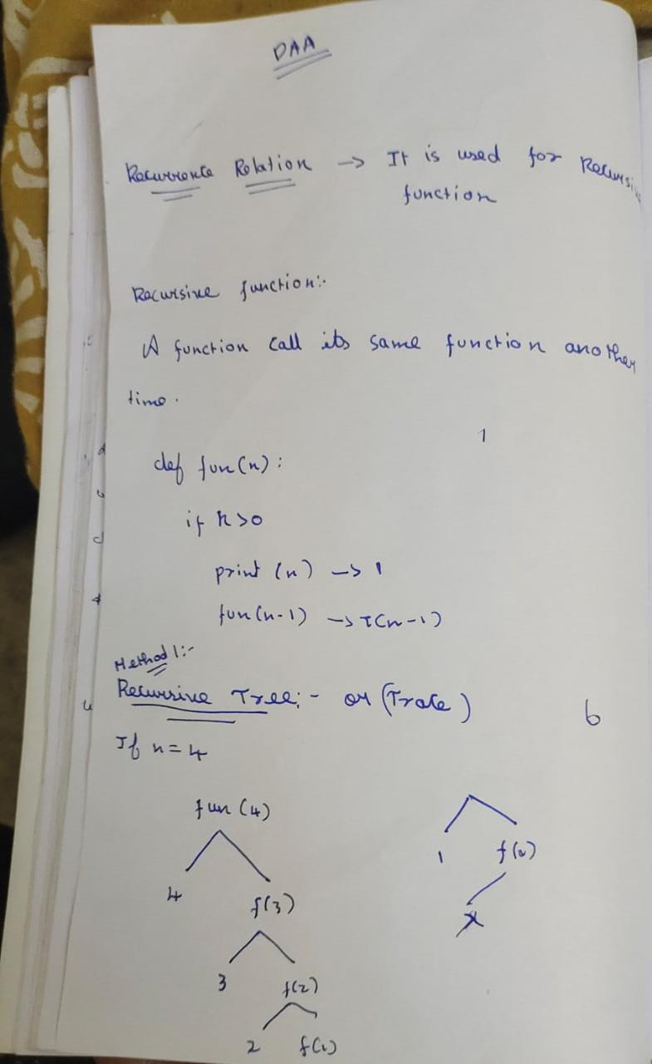hod

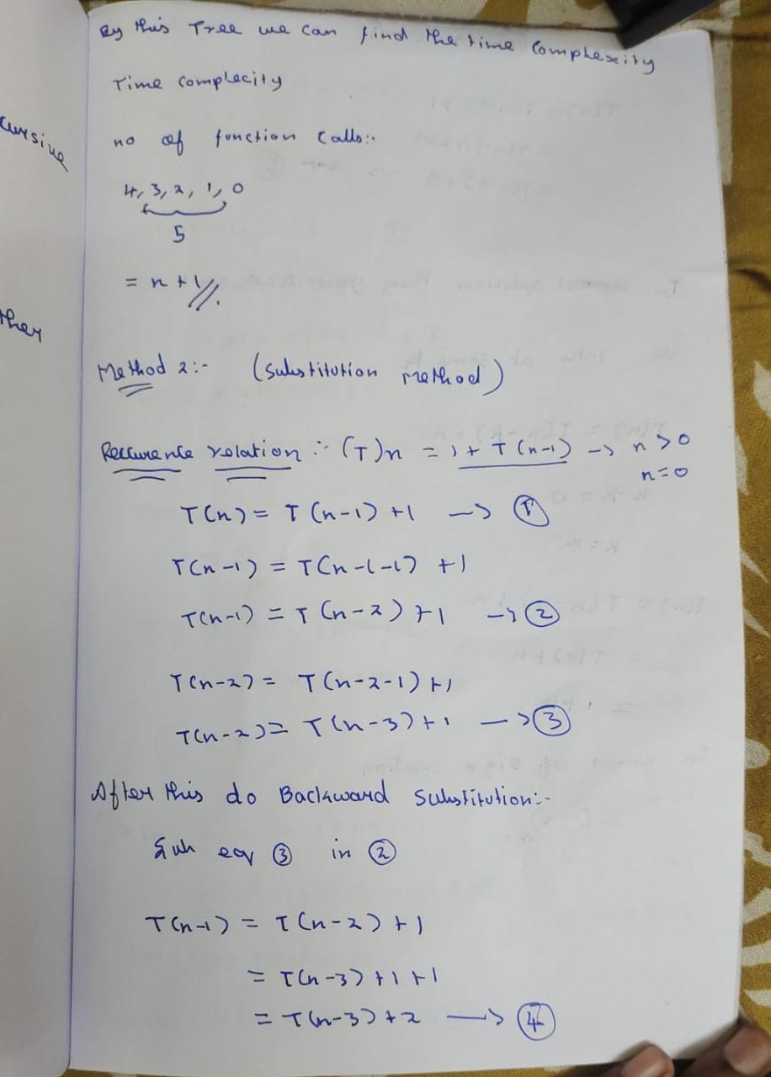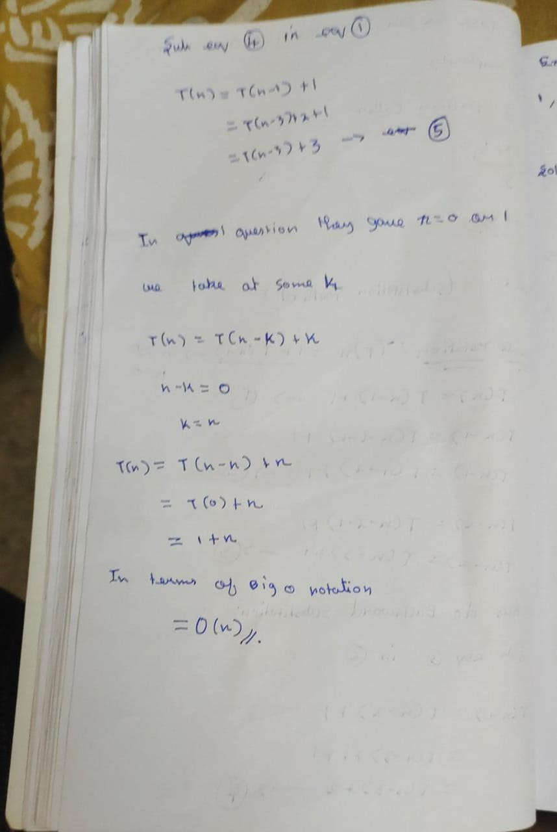

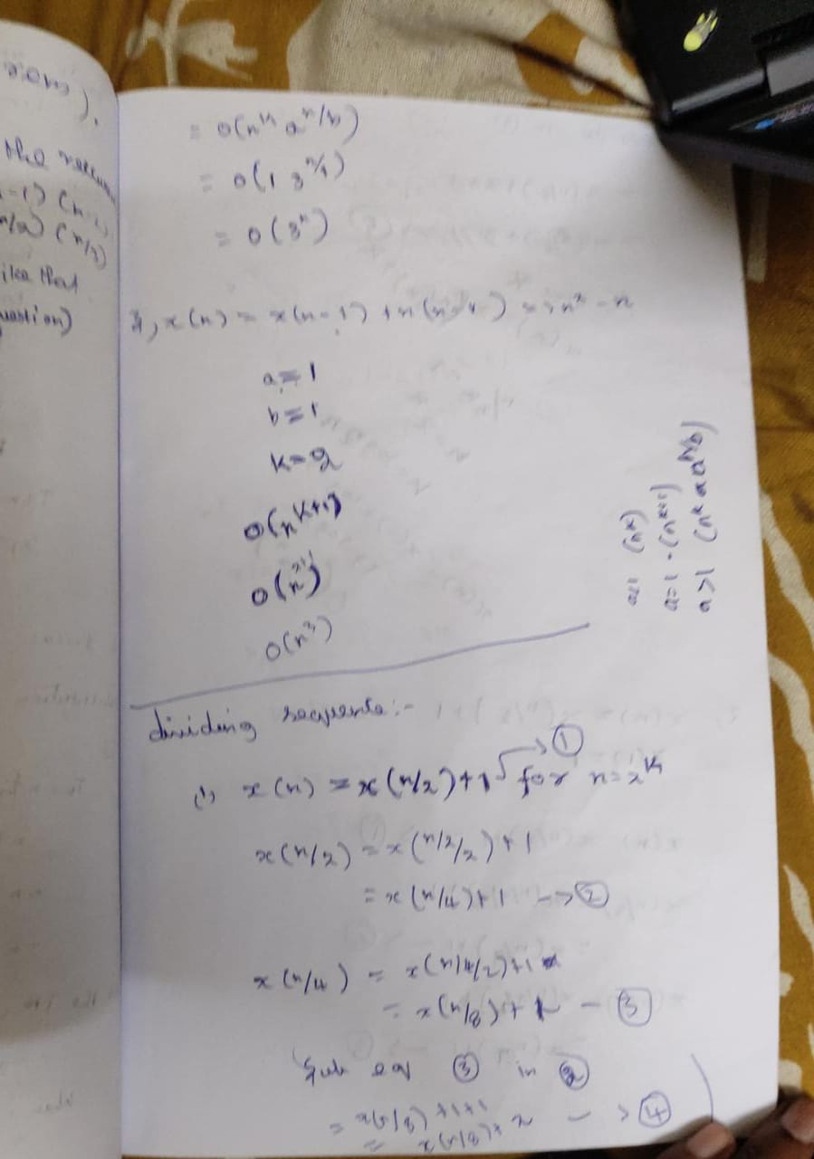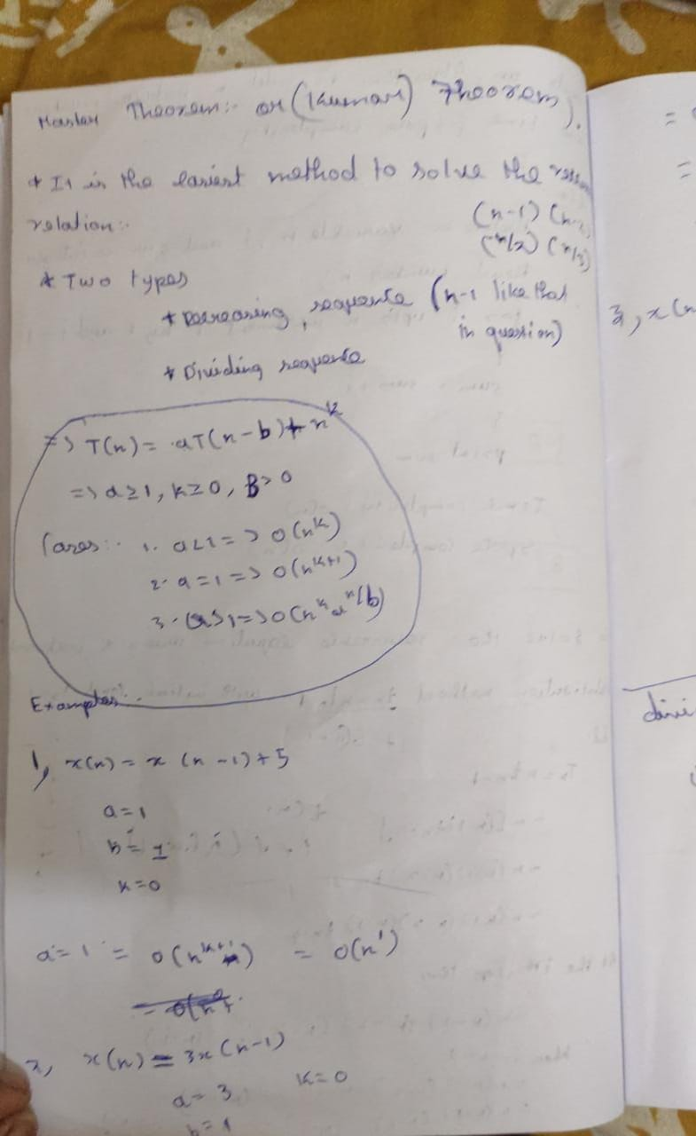

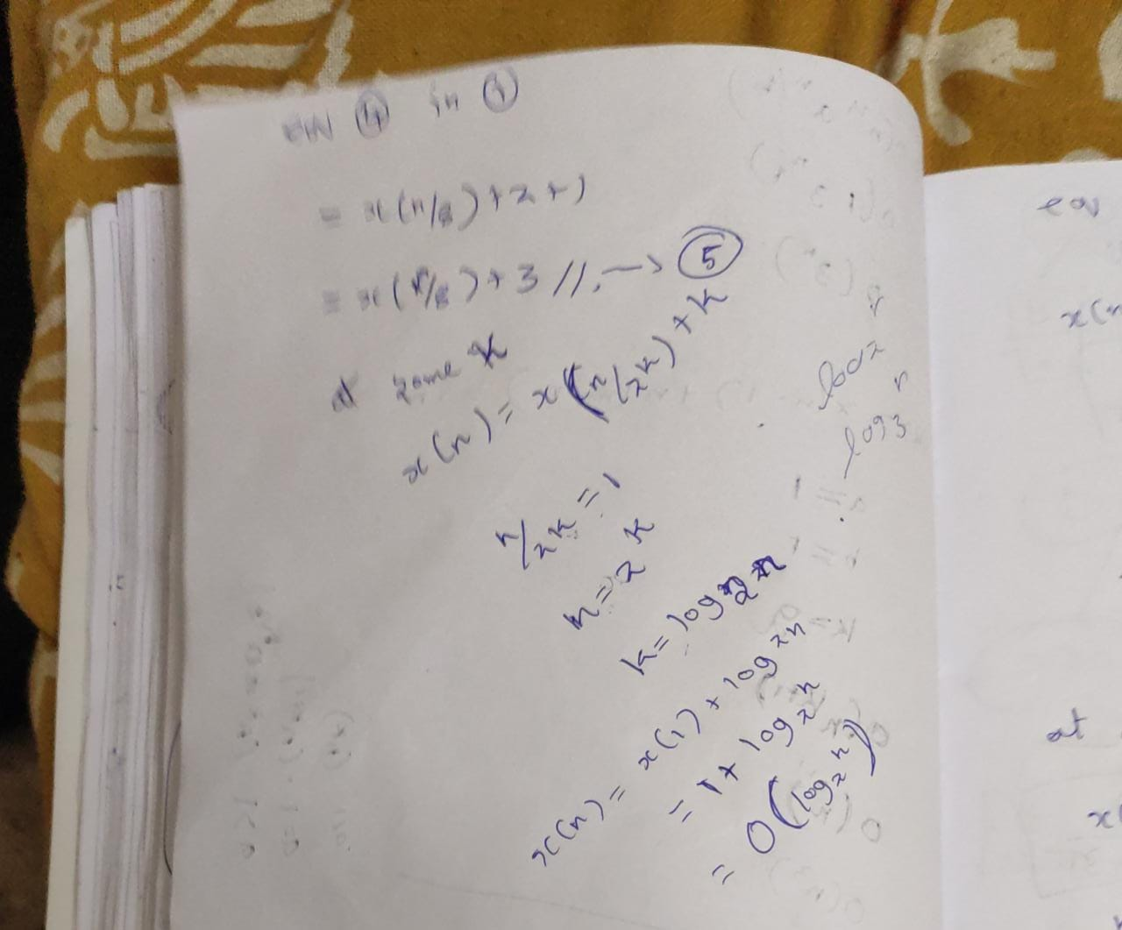

Time space complexity

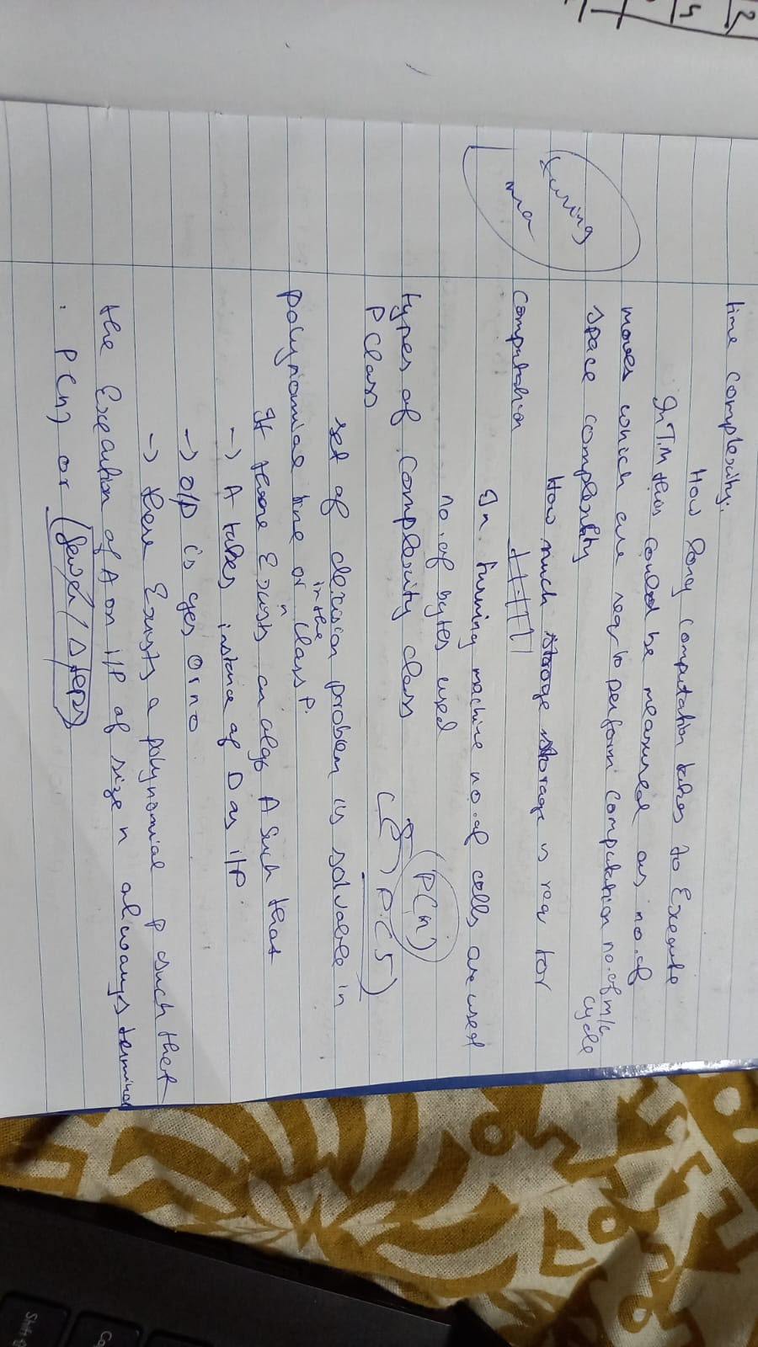

3.maximum sub array

max min of array same method

4.binary search

binarySearch(arr, x, low, high)

repeat till low = high

mid = (low + high)/2

if (x == arr[mid])

return mid

else if (x > arr[mid]) // x is on the right side

low = mid + 1

else // x is on the left side

high = mid – 1

5. quick sort

QUICKSORT (array A, start, end)

{

1 if (start < end)

2 {

3 p = partition(A, start, end)

4 QUICKSORT (A, start, p - 1)

5 QUICKSORT (A, p + 1, end)

6 }

}

PARTITION (array A, start, end)

{

1 pivot ? A[end]

2 i ? start-1

3 for j ? start to end -1 {

4 do if (A[j] < pivot) {

5 then i ? i + 1

6 swap A[i] with A[j]

7 }}

8 swap A[i+1] with A[end]

9 return i+1

}

Merge sort

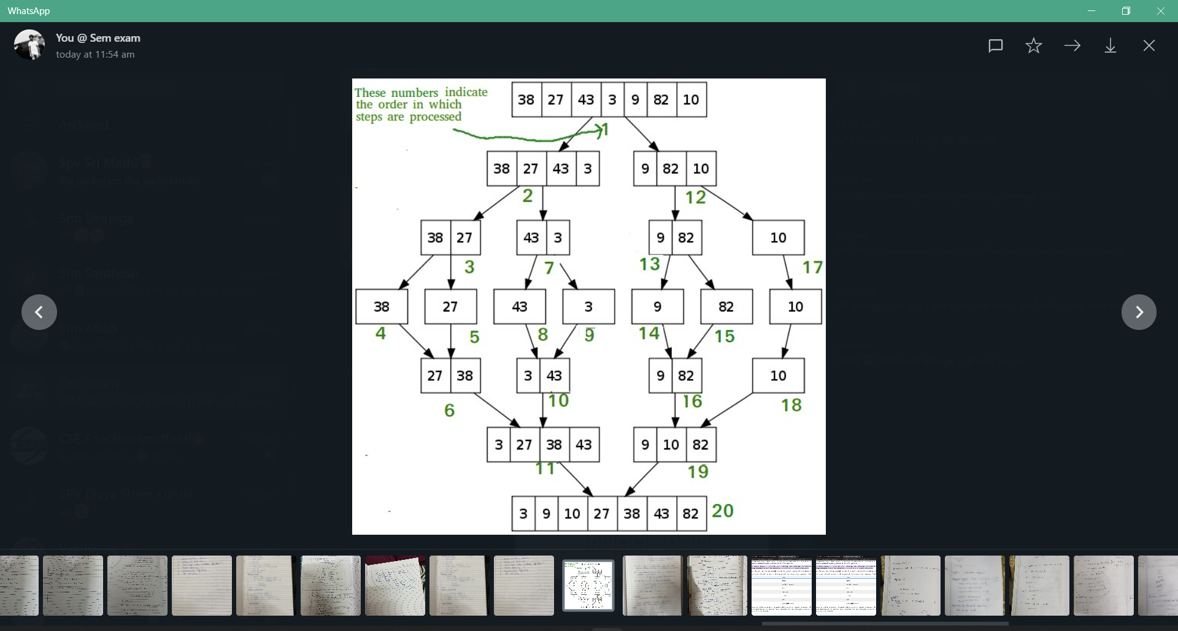

st matrix multiplication

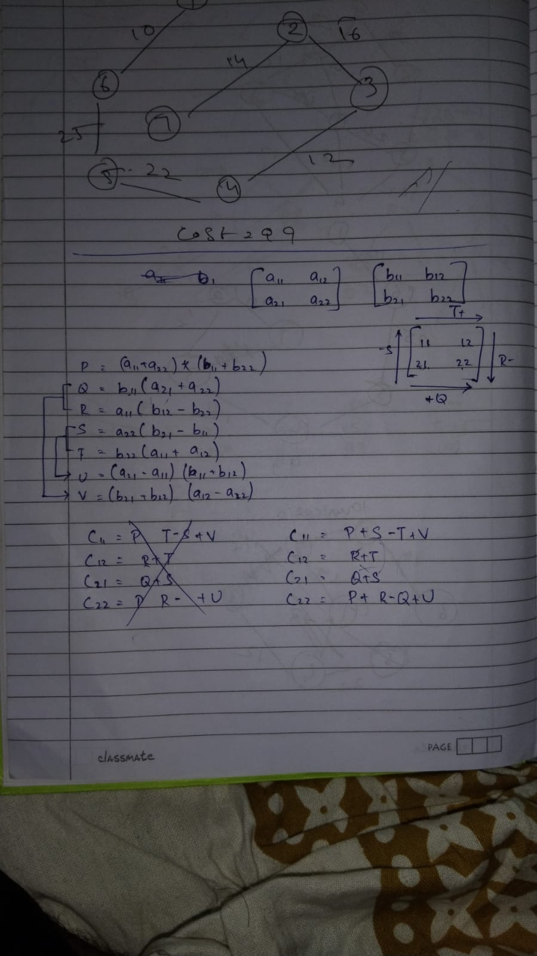

Find max min of array

Divide and conquer

8.convex hull

<https://youtu.be/UUCKvHTP4Gg>

9. closest pair problem

<https://youtu.be/nlqCg6afqoE>

11. Huffman coding

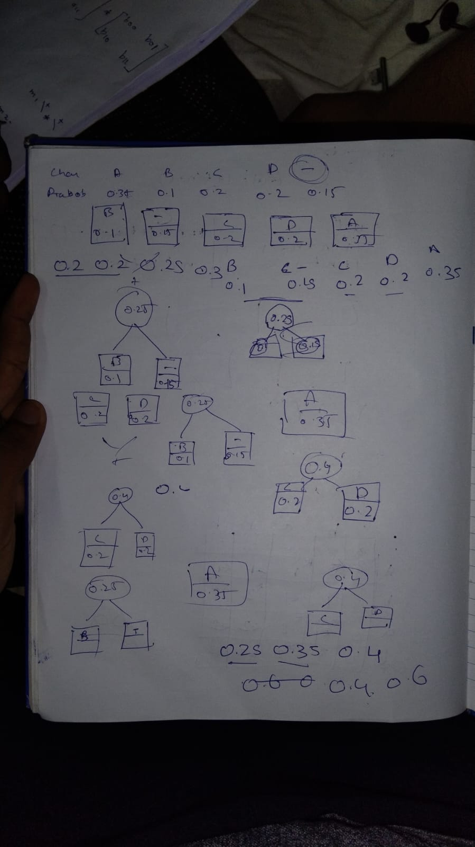

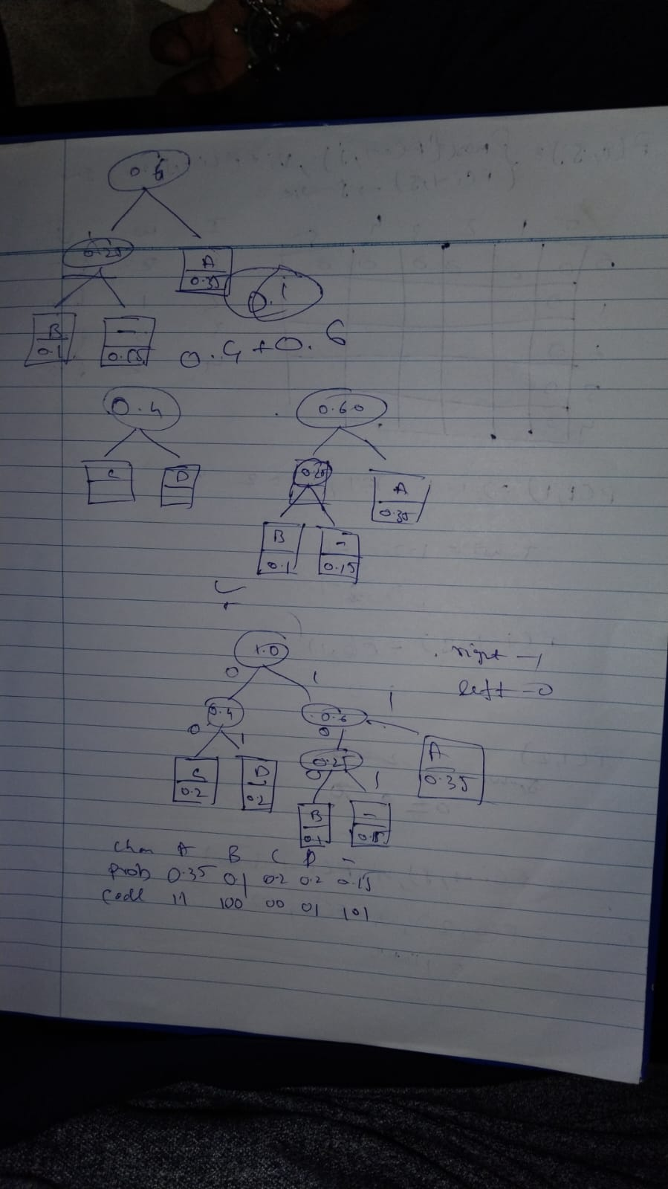

12.knapsack prob- fractional method

<https://www.javatpoint.com/fractional-knapsack-problem>

.13tree traversal- min spanning tree, shortest path

Prims

Krushkal’s

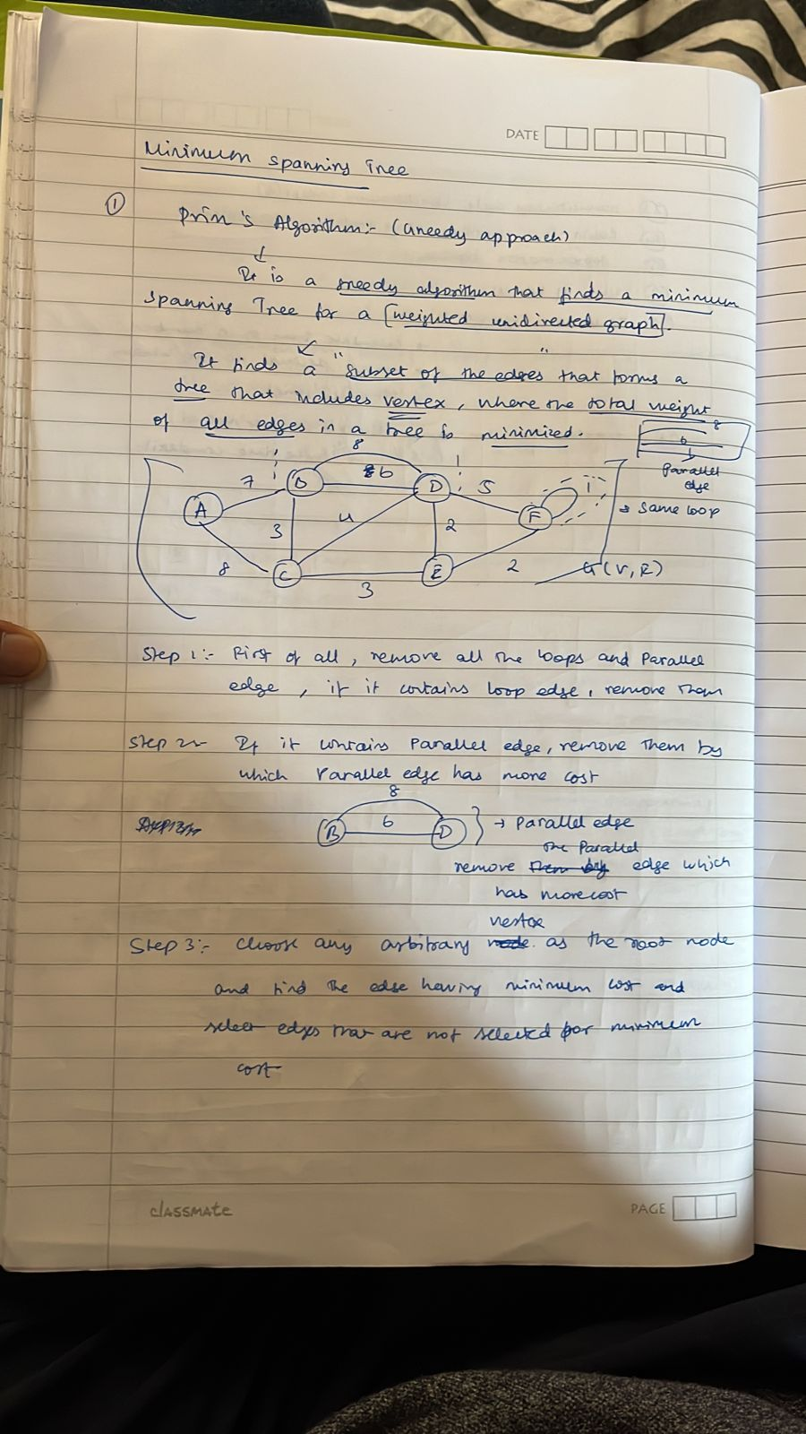

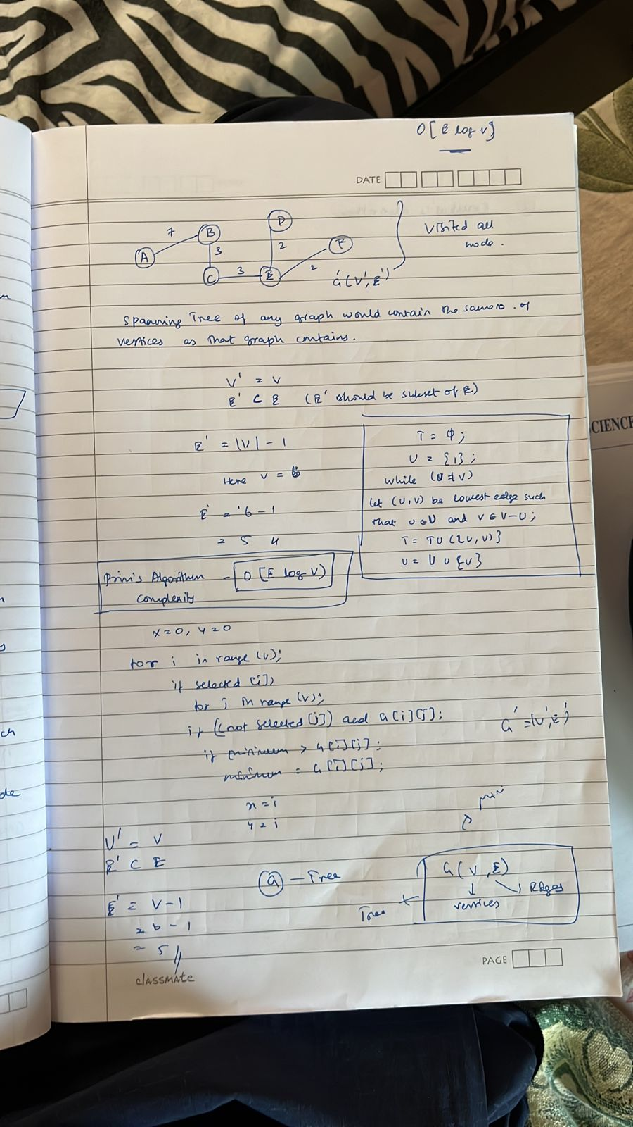

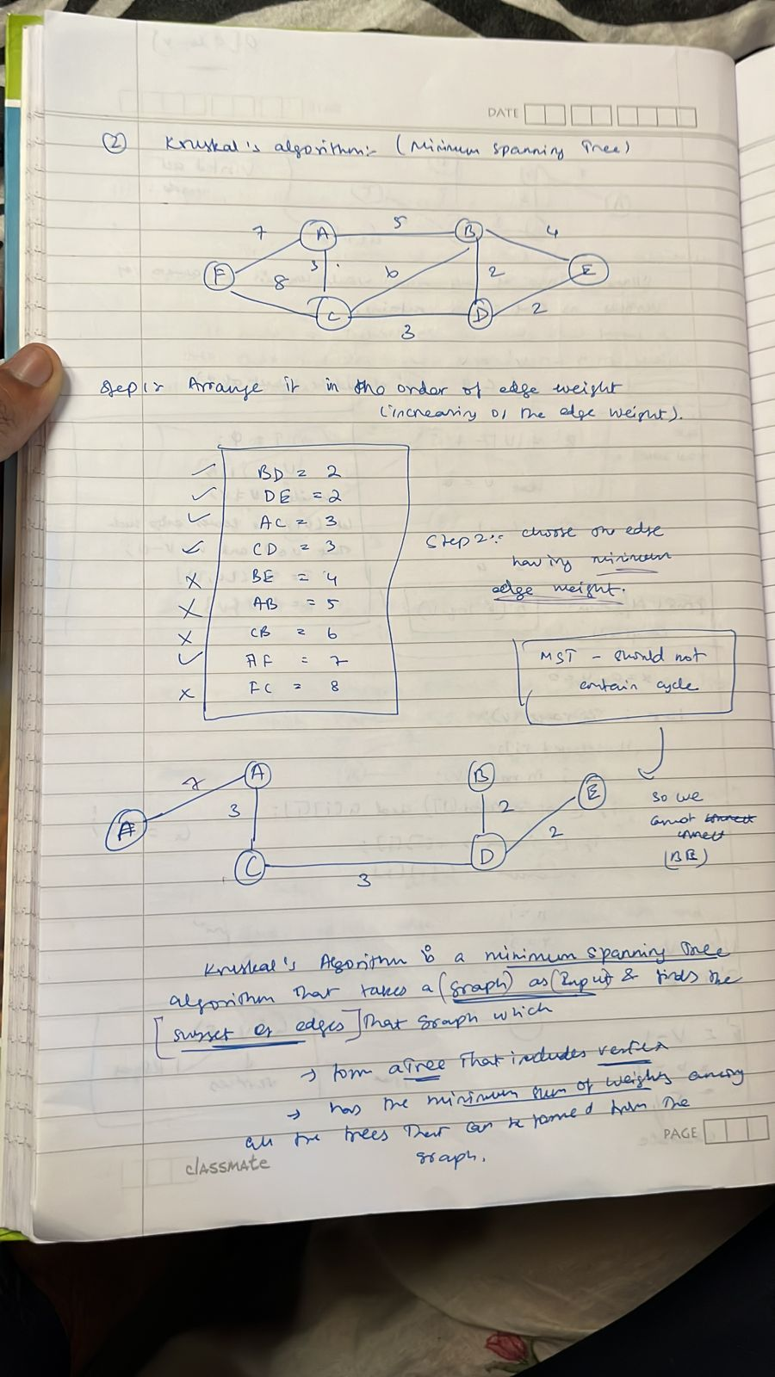

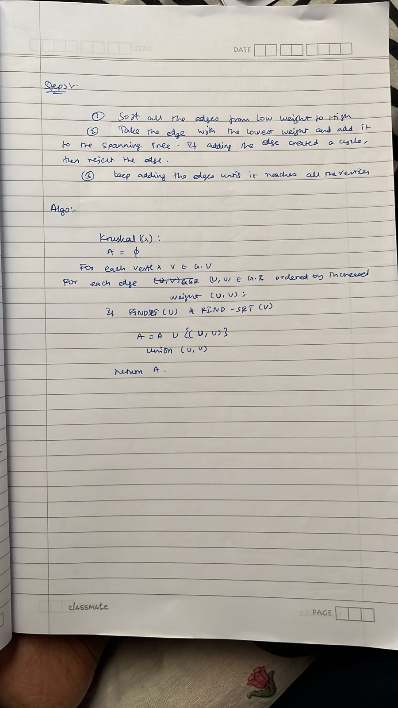

matrix chain mult

<https://youtu.be/prx1psByp7U>

longest common subsequence

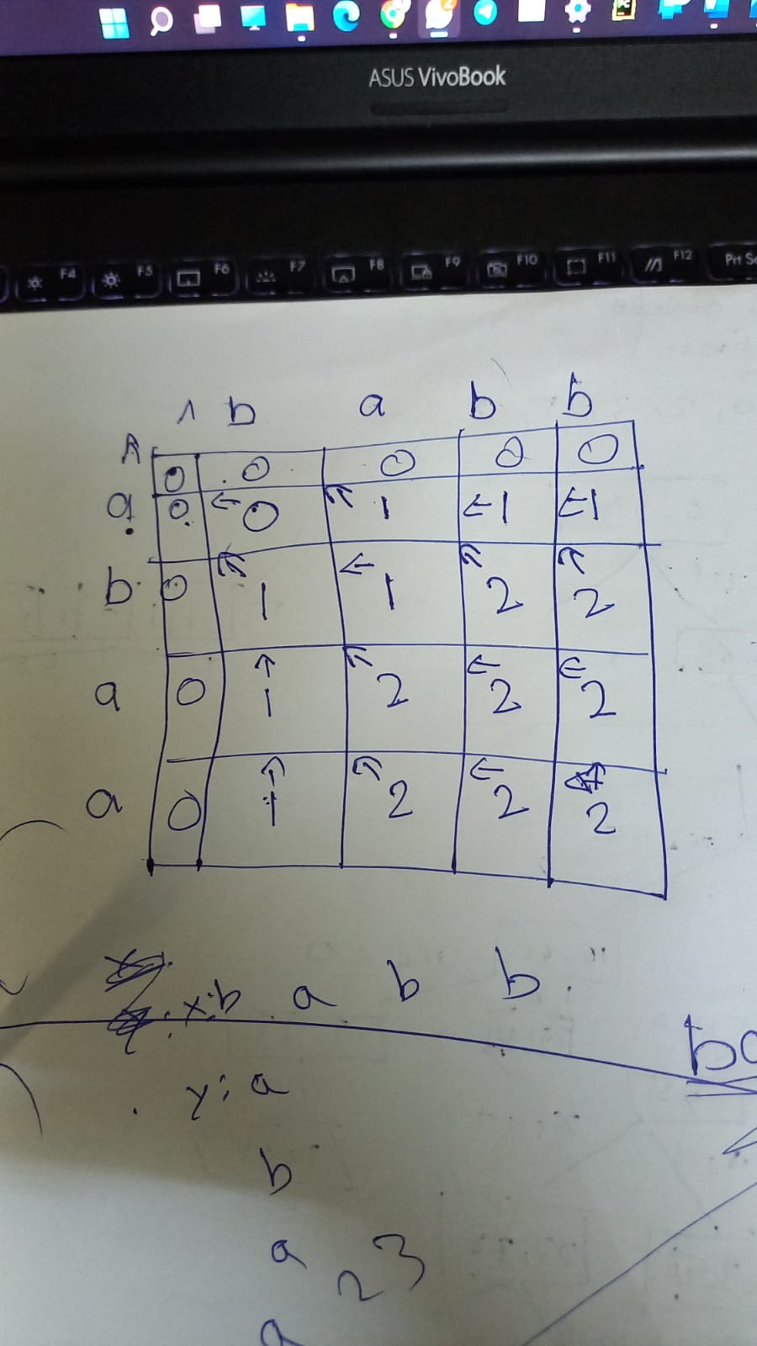

18. n-queens

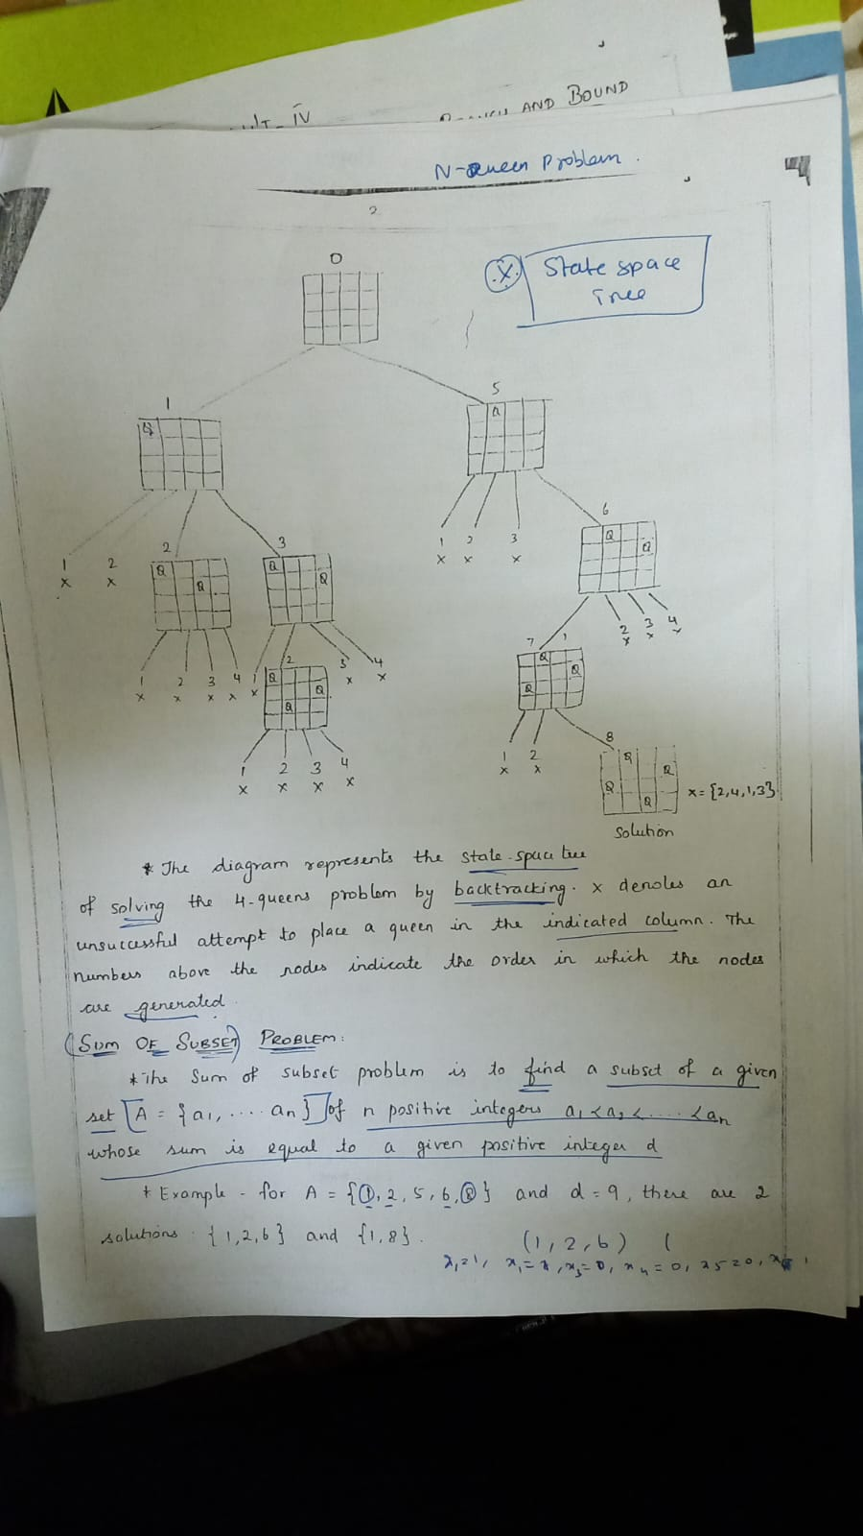

Sum of subset

<https://youtu.be/kyLxTdsT8ws>

Hamilton cycle

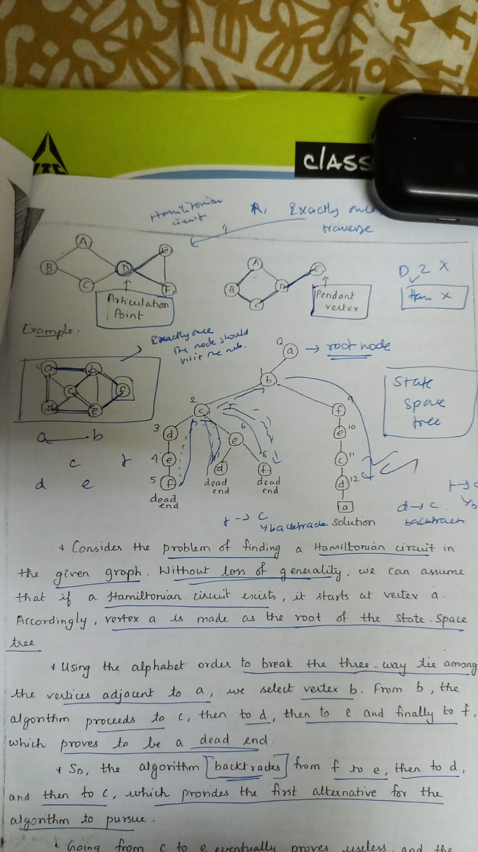

travelling salesman

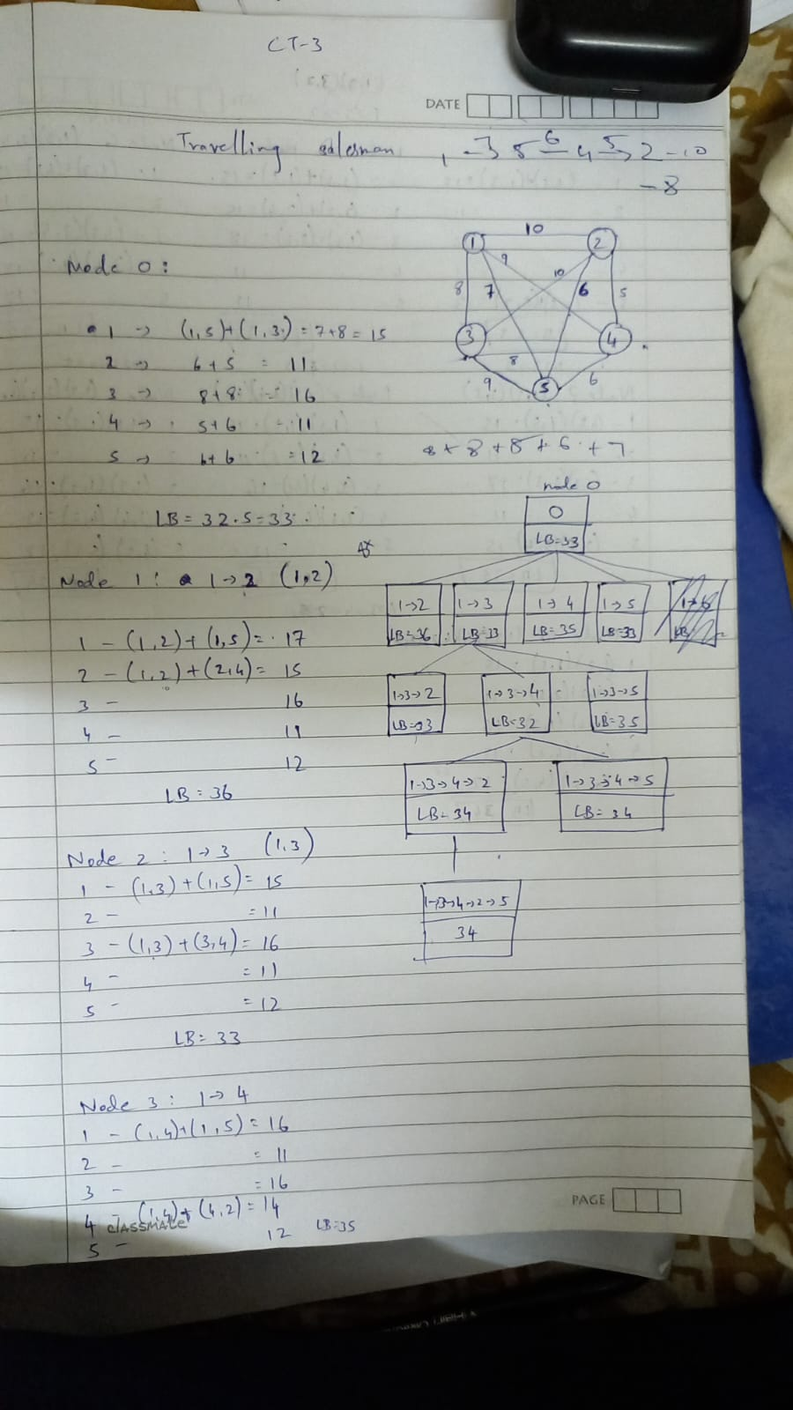

Floyd warshall

<https://youtu.be/Gc4mWrmJBsw>

randomized hiring prob

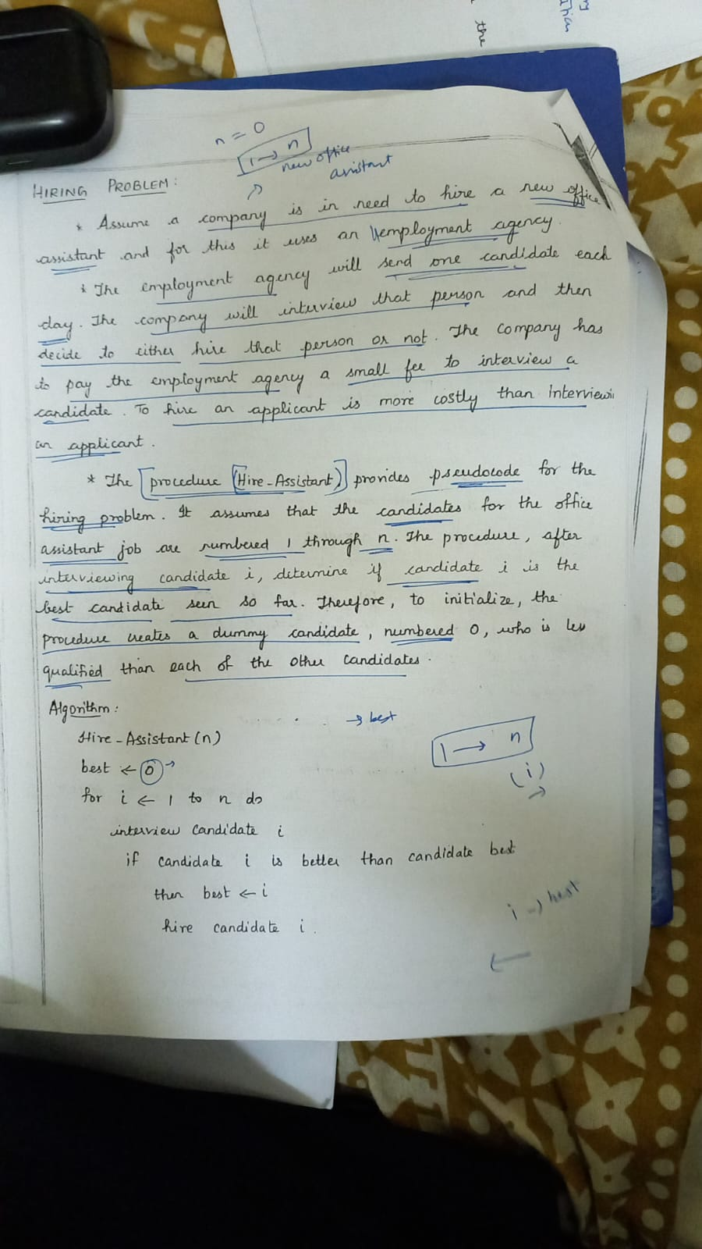

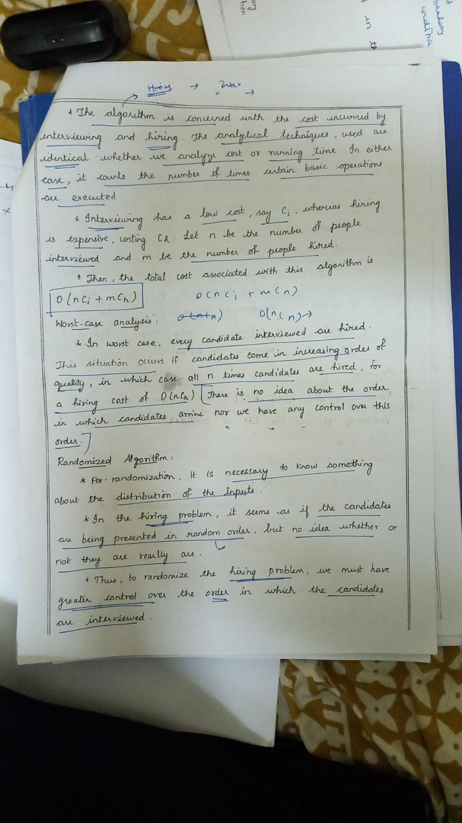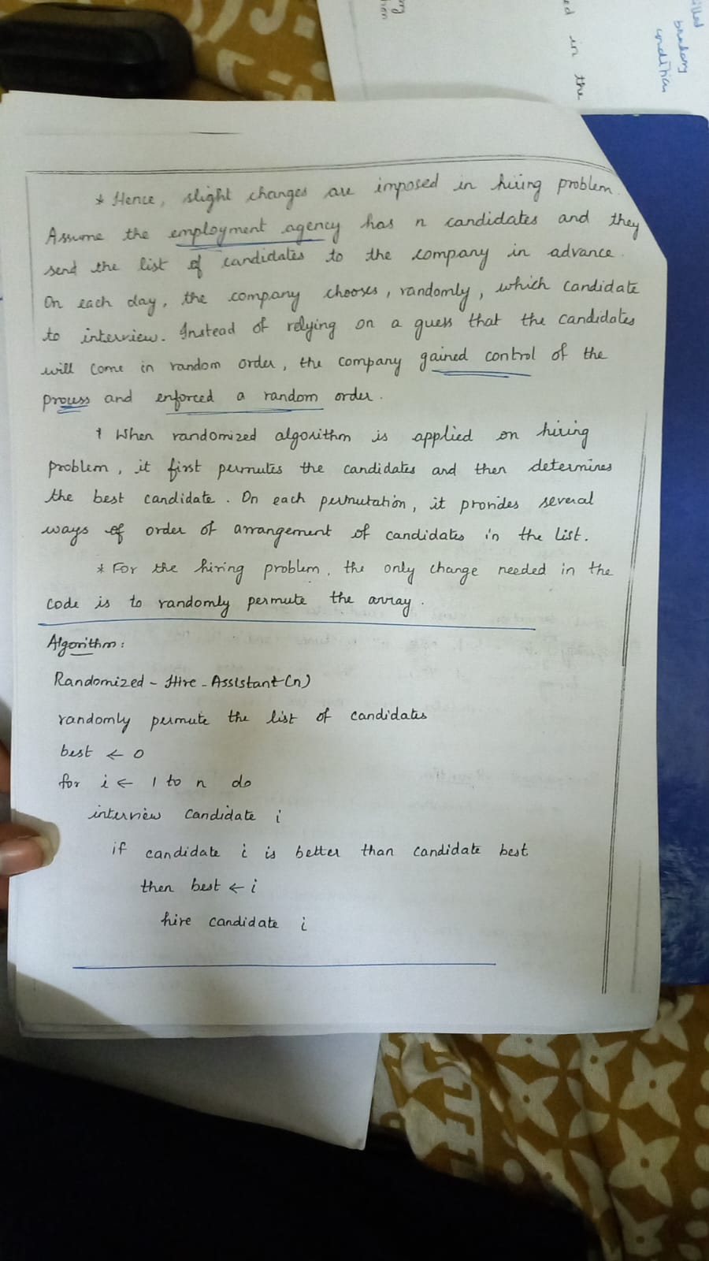

randomized quick sort

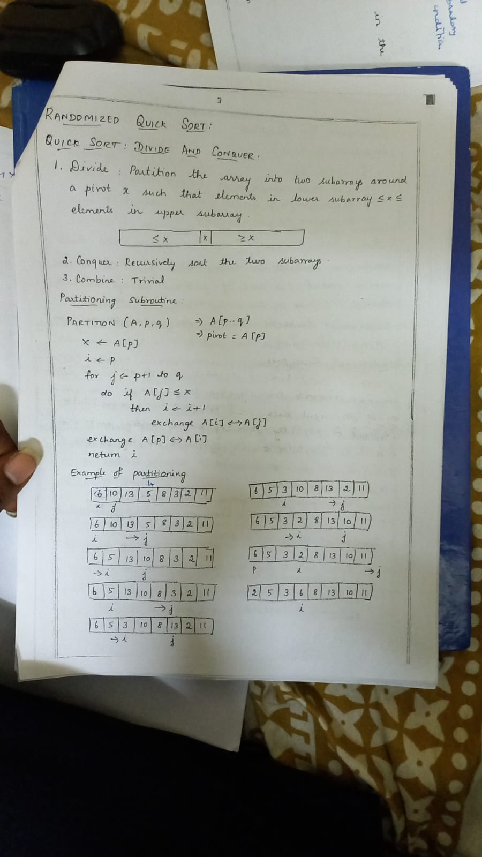

vertex covering

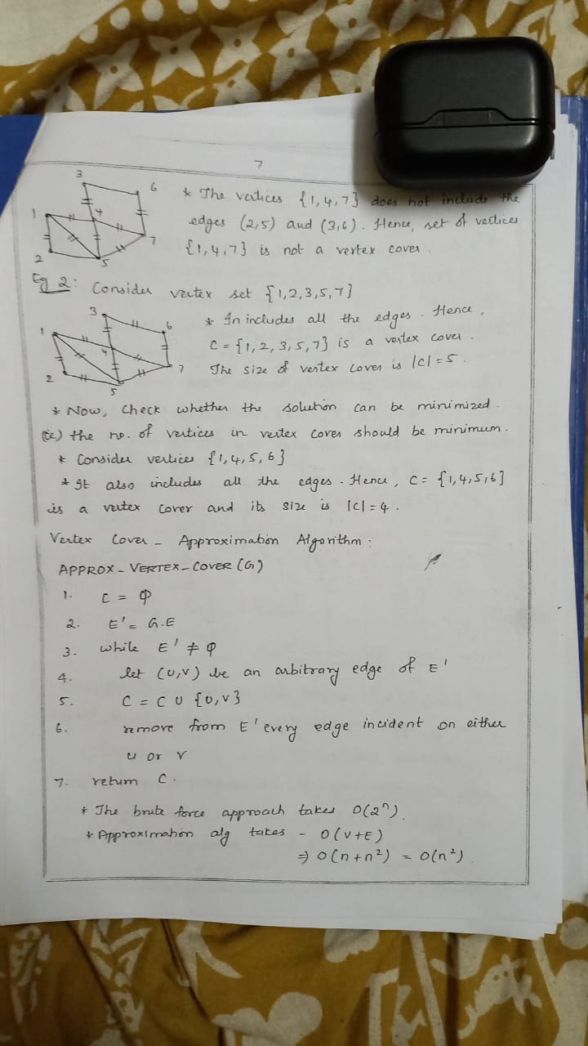

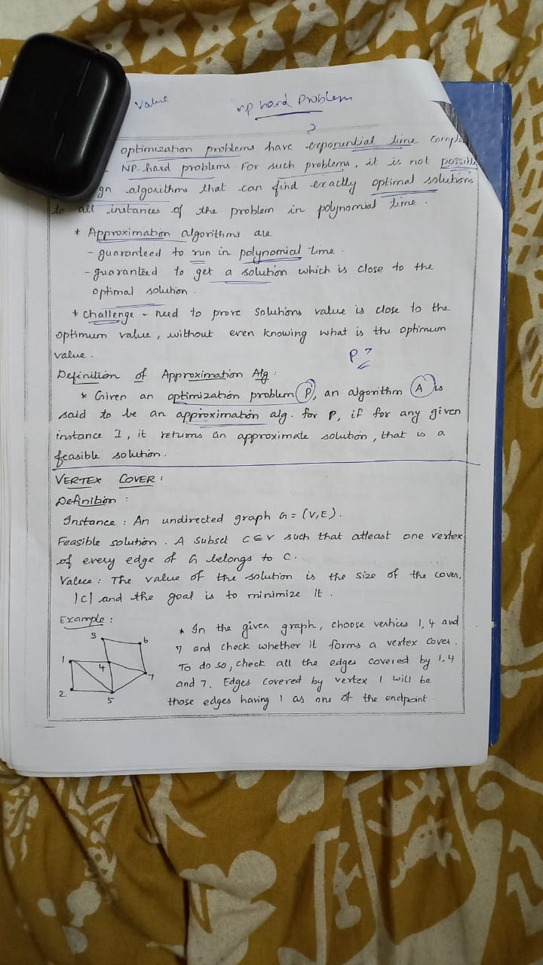

complexity classes

